Dibcase ERE Upload/Download Utility
  - Quick Start Guide
A practical launch-ready guide for setting up representatives, connecting to SSA ERE, running daily ZIP intake, pulling full files, staging uploads, and reviewing reports.
Audience: Firm owners, representatives, and staff who need a reliable daily operating rhythm for ERE downloads and uploads.
Screenshot Note: All screenshots in this guide use sanitized sample names, SSNs, and folders so the guide is safe for sales, onboarding, and training.

Start Here
Use this order for a normal production day. It keeps reports, downloads, full-file requests, and uploads separated so staff can see what happened and where the files landed.
- Confirm the active representative and license context.
- Open Connection, complete SSA ERE sign-in and 2FA, then verify the session.
- Open Daily Run, paste SSNs, review Queue Preview, choose New Only for routine ZIP intake, and run downloads.
- Use Reports to pull ERE spreadsheet reports and review status or decision changes.
- Use Full File Queue only when a complete claimant PDF packet is needed.
- Use Staged Uploads for controlled upload preparation and submission through a verified ERE session.

Before The First Run
Requirement | What To Confirm
License | A valid Dibcase license key is active for the firm and representative.
Representative profile | Name, REP/ERE user ID, optional inbox override, and saved credentials are correct.
SSA ERE access | The user can sign in and complete the temporary passcode challenge when SSA asks.
Storage folders | Firm inbox fallback, backup folder, and shared staged-upload folder are reachable.
Workflow choice | Daily Run is ZIP-centric; use Full File Queue for complete PDF packets.

1. Set the representative context
- Select the representative who is doing the work.
- Confirm the ERE User ID and inbox routing.
- Use Edit Profile when credentials, license key, or inbox override changes.
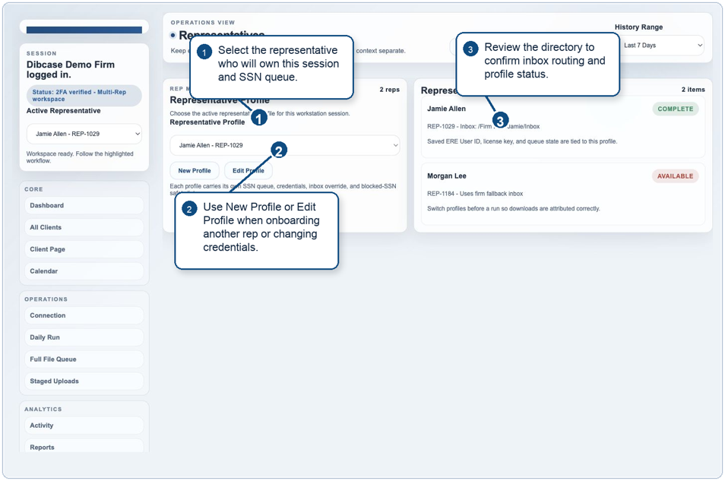
Figure 1. Representatives - select the active profile before any ERE workflow.

2. Connect and verify ERE
- Open Connection from the Operations menu.
- Confirm user ID/password and check the SSA certification box.
- Use Open ERE Login + Verify Session, finish SSA 2FA, then wait for the app to show verified status.
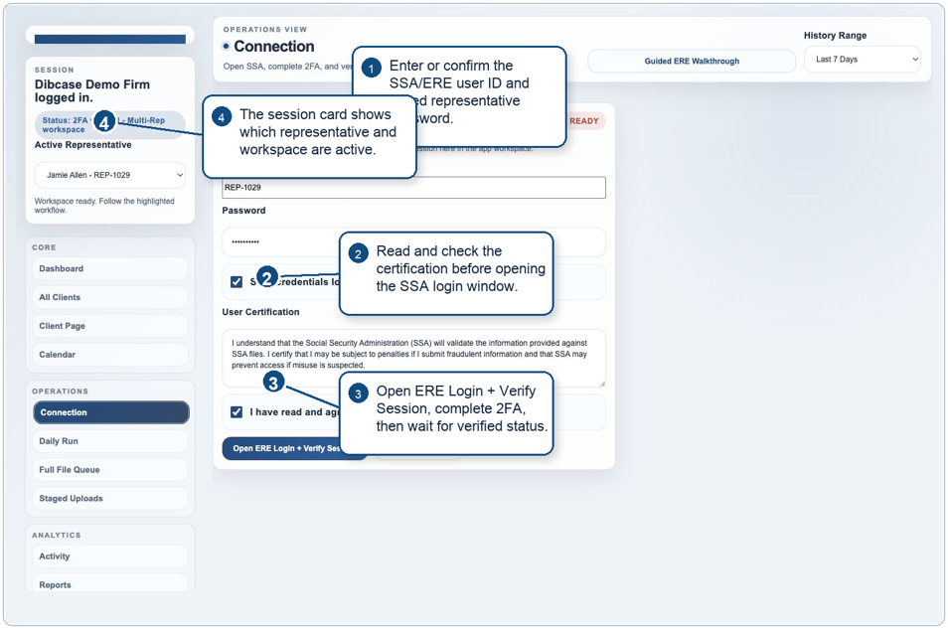
Figure 2. Connection - verify the ERE session after SSA sign-in and 2FA.

3. Run daily ZIP intake
- Paste SSNs into Active SSN List; the app normalizes common SSN formats.
- Review Queue Preview before starting, especially client matches and archived clients.
- Use New Only for routine daily ZIP retrieval; use Full File Queue for complete PDFs.
- Watch Download / Conversion Status until every row completes, queues, or needs review.
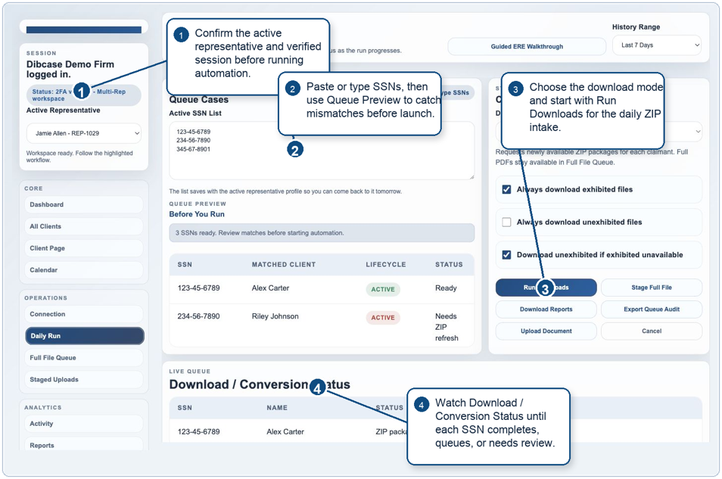
Figure 3. Daily Run - queue SSNs, choose the download mode, and monitor status.

4. Review reports and changes
- Download Reports at the start of the day or whenever status visibility matters.
- Review tracked cases, status changes, and decision changes.
- To spot recent changes quickly, use any of three views: sort the All Clients client list by "Status Date," check the Calendar, or review the status panels on the Dashboard.
- Export changes when staff need a portable review packet outside the app.
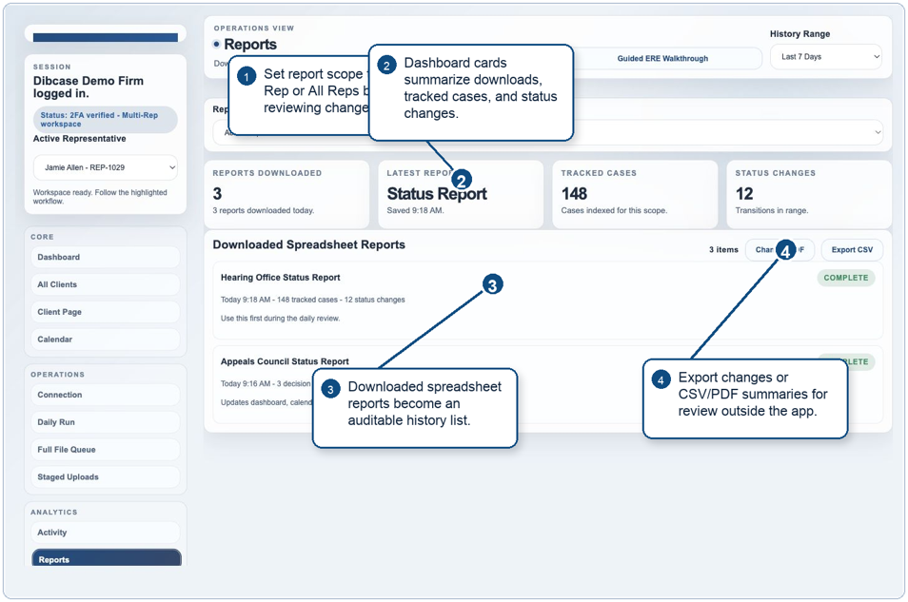
Figure 4. Reports - download spreadsheets and review status or decision changes.

5. Pull full files when needed
- Stage full-file requests for selected claimants only.
- Choose Full Folder to PDF or Full Exhibited to PDF based on what the case needs.
- Run staged requests after the ERE session is verified.
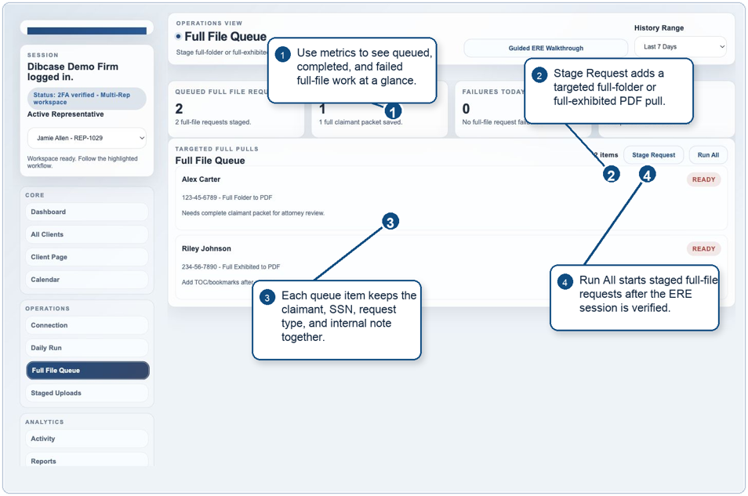
Figure 5. Full File Queue - run targeted full-folder or full-exhibited PDF pulls.

6. Stage and upload documents
- Stage files with claimant SSN and document type before submission.
- Use the shared staged-upload folder for cross-machine handoff.
- Upload only after the representative has a verified ERE session.
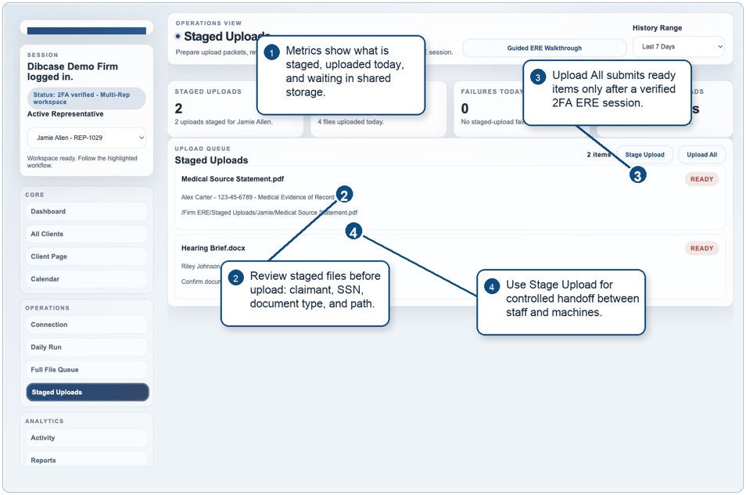
Figure 6. Staged Uploads - prepare documents for controlled ERE upload submission.

7. Maintain workspace settings
- Run Guided Setup when onboarding a new firm or workstation.
- Keep firm inbox, backup, and staged-upload paths accurate.
- Use Browse buttons for exact folder paths instead of manual typing.
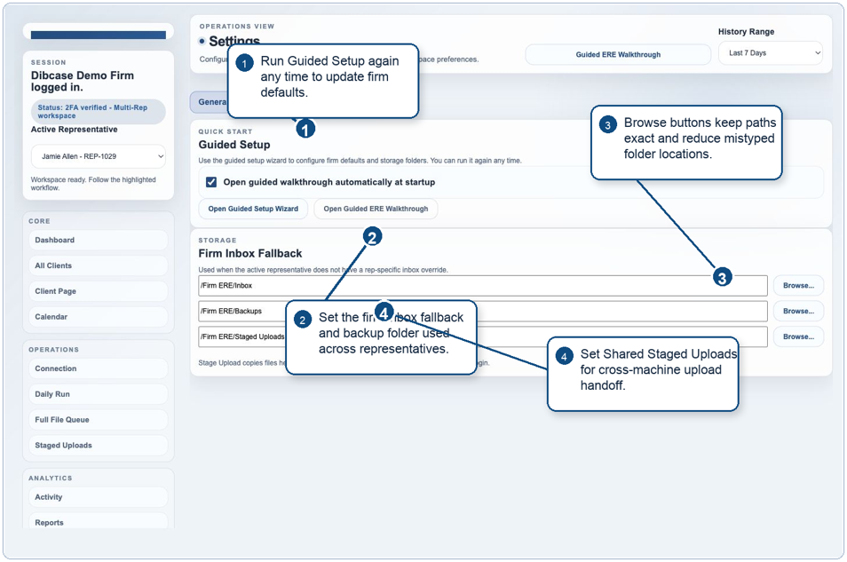
Figure 7. Settings - configure guided setup, storage paths, and shared upload folders.

Quick Reference
The table below is the fastest way to answer "where do I go next?" during a live workday. For recent case changes, use three fast views: sort the All Clients client list by "Status Date," check the Calendar, or review the status panels on the Dashboard.
Task | Go To | ERE Session | Expected Output
Activate or manage license | Brand/session card or Representative Profile | No | License status updates in the app.
Verify ERE session | Connection | Yes | Logged-in/verified session state.
Routine new-file intake | Daily Run -> New Only | Yes | ZIP packages extracted into the active rep inbox.
Complete claimant packet | Full File Queue | Yes | Full-folder or full-exhibited PDF request/download.
Download spreadsheets | Reports or Daily Run -> Download Reports | May require ERE access | Status, decision, and case reports saved to backup/report history.
Submit documents | Staged Uploads | Yes | Upload receipts and activity history.
Find recent case changes | All Clients / Calendar / Dashboard | No | Recent updates surfaced by Status Date sorting, calendar items, or dashboard status panels.

Troubleshooting
Session expired or login failure: Return to Connection, complete SSA sign-in/2FA again, and verify before rerunning downloads or uploads.
No new files: This is normal when ERE has no newly available documents for that claimant. Use Full File Queue only if a complete packet is needed.
Access denied or blocked SSN: Do not repeatedly retry. Review Risk Watch and confirm access manually before unblocking.
Files landed in the wrong folder: Check the active representative first, then verify the rep inbox override and firm inbox fallback in Settings.
Upload queue does nothing: Confirm the staged item has claimant SSN, supported file, document type, and verified ERE session.
Launch Tip: For sales demos, start with Representatives, Connection, Daily Run, Reports, Full File Queue, and Staged Uploads. That sequence shows the full product story without requiring real client data.

